In the Node-RED window, at the top right corner, select the menu, and go to **Import** > **Clipboard**.

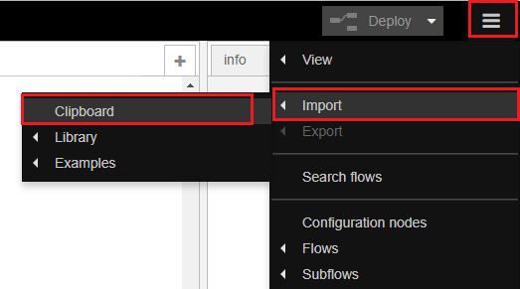

Then, paste the code provided and click **Import**.

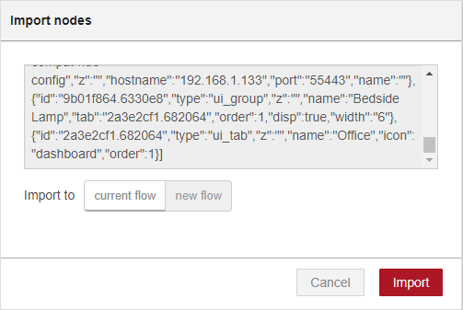

[{"id":"9e58624.7faaba","type":"mqtt out","z":"c02b79b2.501998","name":"","topic":"esp32/output","qos":"","retain":"","broker":"10e78a89.5b4fd5","x":610,"y":342,"wires":[]},{"id":"abf7079a.653be8","type":"mqtt in","z":"c02b79b2.501998","name":"","topic":"esp32/temperature","qos":"2","broker":"10e78a89.5b4fd5","x":484,"y":249,"wires":[["cc79021b.9a751","21eae8f8.2971b8"]]},{"id":"83cf37cf.c76988","type":"ui_switch","z":"c02b79b2.501998","name":"","label":"Output","group":"61285987.c20328","order":0,"width":0,"height":0,"passthru":true,"decouple":"false","topic":"","style":"","onvalue":"on","onvalueType":"str","onicon":"","oncolor":"","offvalue":"off","offvalueType":"str","officon":"","offcolor":"","x":469,"y":342,"wires":[["9e58624.7faaba"]]},{"id":"cc79021b.9a751","type":"debug","z":"c02b79b2.501998","name":"","active":true,"tosidebar":true,"console":false,"tostatus":false,"complete":"false","x":681,"y":216,"wires":[]},{"id":"4aecba01.78ce64","type":"mqtt in","z":"c02b79b2.501998","name":"","topic":"esp32/humidity","qos":"2","broker":"10e78a89.5b4fd5","x":473,"y":133,"wires":[["22efa7b7.544a28","df37e6b7.64c1c8"]]},{"id":"22efa7b7.544a28","type":"debug","z":"c02b79b2.501998","name":"","active":true,"tosidebar":true,"console":false,"tostatus":false,"complete":"false","x":670,"y":100,"wires":[]},{"id":"21eae8f8.2971b8","type":"ui_chart","z":"c02b79b2.501998","name":"","group":"61285987.c20328","order":0,"width":0,"height":0,"label":"Temperature","chartType":"line","legend":"false","xformat":"HH:mm:ss","interpolate":"linear","nodata":"","dot":false,"ymin":"","ymax":"","removeOlder":1,"removeOlderPoints":"","removeOlderUnit":"3600","cutout":0,"useOneColor":false,"colors":["#1f77b4","#aec7e8","#ff7f0e","#2ca02c","#98df8a","#d62728","#ff9896","#9467bd","#c5b0d5"],"useOldStyle":false,"x":681,"y":276,"wires":[[],[]]},{"id":"df37e6b7.64c1c8","type":"ui_gauge","z":"c02b79b2.501998","name":"","group":"61285987.c20328","order":0,"width":0,"height":0,"gtype":"gage","title":"Humidity","label":"%","format":"{{value}}","min":0,"max":"100","colors":["#00b3d9","#0073e6","#001bd7"],"seg1":"33","seg2":"66","x":660,"y":160,"wires":[]},{"id":"10e78a89.5b4fd5","type":"mqtt-broker","z":"","name":"","broker":"localhost","port":"1883","clientid":"","usetls":false,"compatmode":true,"keepalive":"60","cleansession":true,"birthTopic":"","birthQos":"0","birthPayload":"","closeTopic":"","closeQos":"0","closePayload":"","willTopic":"","willQos":"0","willPayload":""},{"id":"61285987.c20328","type":"ui_group","z":"","name":"Main","tab":"e7c46d5e.a1283","disp":true,"width":"6","collapse":false},{"id":"e7c46d5e.a1283","type":"ui_tab","z":"","name":"Dashboard","icon":"dashboard"}]

[{"id":"9e58624.7faaba",

"type":"mqtt out",

"z":"c02b79b2.501998",

"name":"",

"topic":"esp32/output",

"qos":"",

"retain":"",

"broker":"10e78a89.5b4fd5",

"x":610,"y":342,

"wires":[]},

{"id":"abf7079a.653be8",

"type":"mqtt in",

"z":"c02b79b2.501998",

"name":"",

"topic":"esp32/temperature",

"qos":"2",

"broker":"10e78a89.5b4fd5",

"x":484,"y":249,

"wires":[["cc79021b.9a751",

"21eae8f8.2971b8"]]},

{"id":"83cf37cf.c76988",

"type":"ui_switch",

"z":"c02b79b2.501998",

"name":"",

"label":"Output",

"group":"61285987.c20328",

"order":0,

"width":0,"height":0,

"passthru":true,

"decouple":"false",

"topic":"",

"style":"",

"onvalue":"on",

"onvalueType":"str",

"onicon":"",

"oncolor":"",

"offvalue":"off",

"offvalueType":"str",

"officon":"",

"offcolor":"",

"x":469,"y":342,

"wires":[["9e58624.7faaba"]]},

{"id":"cc79021b.9a751",

"type":"debug",

"z":"c02b79b2.501998",

"name":"",

"active":true,

"tosidebar":true,

"console":false,

"tostatus":false,

"complete":"false",

"x":681,"y":216,

"wires":[]},

{"id":"4aecba01.78ce64",

"type":"mqtt in",

"z":"c02b79b2.501998",

"name":"",

"topic":"esp32/humidity",

"qos":"2",

"broker":"10e78a89.5b4fd5","x":473,"y":133,

"wires":[["22efa7b7.544a28","df37e6b7.64c1c8"]]},

{"id":"22efa7b7.544a28",

"type":"debug",

"z":"c02b79b2.501998",

"name":"",

"active":true,

"tosidebar":true,

"console":false,

"tostatus":false,

"complete":"false",

"x":670,"y":100,

"wires":[]},

{"id":"21eae8f8.2971b8",

"type":"ui_chart",

"z":"c02b79b2.501998",

"name":"",

"group":"61285987.c20328",

"order":0,

"width":0,"height":0,

"label":"Temperature",

"chartType":"line",

"legend":"false",

"xformat":"HH:mm:ss",

"interpolate":"linear",

"nodata":"",

"dot":false,

"ymin":"","ymax":"",

"removeOlder":1,

"removeOlderPoints":"",

"removeOlderUnit":"3600",

"cutout":0,

"useOneColor":false,

"colors":["#1f77b4","#aec7e8","#ff7f0e","#2ca02c","#98df8a","#d62728","#ff9896","#9467bd","#c5b0d5"],

"useOldStyle":false,

"x":681,"y":276,

"wires":[[],[]]},

{"id":"df37e6b7.64c1c8",

"type":"ui_gauge",

"z":"c02b79b2.501998","name":"",

"group":"61285987.c20328",

"order":0,"width":0,"height":0,

"gtype":"gage",

"title":"Humidity",

"label":"%",

"format":"{{value}}",

"min":0,"max":"100",

"colors":["#00b3d9","#0073e6","#001bd7"],

"seg1":"33","seg2":"66",

"x":660,"y":160,"wires":[]},

{"id":"10e78a89.5b4fd5",

"type":"mqtt-broker",

"z":"",

"name":"",

"broker":"localhost",

"port":"1883",

"clientid":"",

"usetls":false,

"compatmode":true,

"keepalive":"60",

"cleansession":true,

"birthTopic":"",

"birthQos":"0",

"birthPayload":"",

"closeTopic":"",

"closeQos":"0",

"closePayload":"",

"willTopic":"",

"willQos":"0",

"willPayload":""},

{"id":"61285987.c20328",

"type":"ui_group",

"z":"",

"name":"Main",

"tab":"e7c46d5e.a1283",

"disp":true,

"width":"6",

"collapse":false},

{"id":"e7c46d5e.a1283",

"type":"ui_tab",

"z":"",

"name":"Dashboard",

"icon":"dashboard"}]

The following nodes should load:

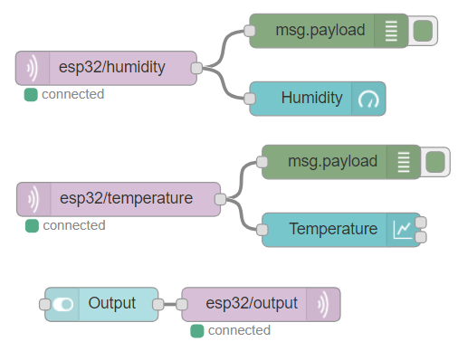

After making any changes, click the **Deploy** button to save all the changes.



Now, your Node-RED application is ready. To access Node-RED UI and see how your application looks, access any browser in your local network and type:

http://**Your_RPi_IP_address:1880**/ui

Your application should look as shown in the following figure.

